Name:

Full working out must be shown to get full marks.
Attempt all questions
Total Time: Part A- 25 mins (28 Marks)
Part B- 35 mins (34 Marks)

Resource Free Section
TIME ALLOWED: 25 min Total marks: 28

- [5 marks: 2, 1, 1, 1]
In a certain group of 60 year 11 students, there are 35 students who study History(H), there are 45 students who study Biology (B) and there are 30 students who study both History and Biology.

- Show this information in the Venn Diagram diagram:
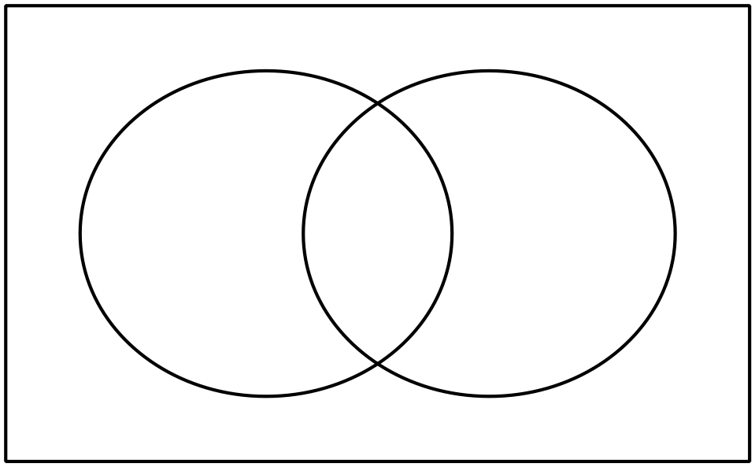
B
H

Find the probability that a selected student:
- only studies History c) does not study History given they study Biology

d) studies either Biology or History

- [3 marks: 1, 2]
Shade the following Venn Diagrams according to the area indicated.

- $A'∪B$ b) $A^{'} ∩ (B∪C)$

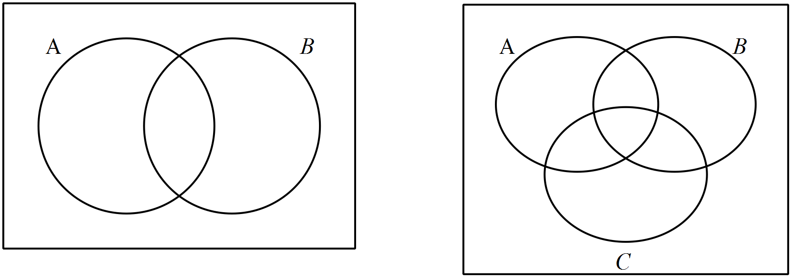

- [5 marks: 2, 2, 1]

Given that $P\left(\overline{A∪B}\right)=0.2 , P\left(B\right)=0.4$and $P\left(A∩B\right)=0.2$;

- Find $P\left(B | A\right).$

- Determine with reasons if the events A and B are independent.

- Determine with reasons if the events A and B are mutually exclusive.

End of Part A

